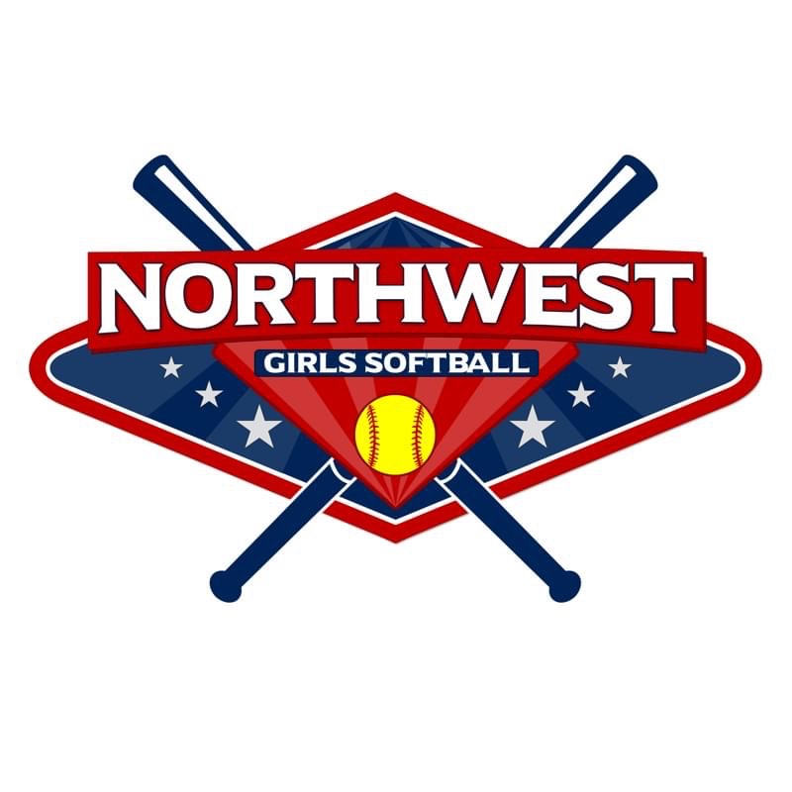
Spring 2024 Uniform Order Form

ORDER FORMS DUE TO UNIFORMS.NWGS@GMAIL.COM
by 5pm Thursday, January 18th.

(Please type directly into this form and email back)

Team Name: |  | Age Division:
Coach Name: |  | Coach Phone #:

Jersey design approved and on file with Turf?:

Pant Color: |  | Sock Color:
 | Belt Color:

Pant Color Options:
Black, Graphite, Gray, Navy, Royal, Scarlet, White

Sock / Belt Color Options:
Black, Brown (belt only), Cardinal, Forest Green, Gold, Hot Pink, Kelly Green, Light Blue, Maroon, Navy, Neon Green, Orange, Pink, Purple, Royal, Scarlet, Teal, Vegas Gold, White

View COLOR and SIZE options below:

Tournament W. T. Low-Rise Pant (champrosports.com) | Multi-Sport Sock (champrosports.com) | MVP Belt (champrosports.com)
Girls: S-XL  Adult: S-3XL  (Please see size guide on  website for more info) | Girls Shoe Size 7-13 (X-Small)  Girls Shoe Size 13-6 (Small)  Girls Shoe Size 6-9 (Medium)  Women’s Shoe Size 10-13 (Large) | Adult - adjusts from 24" to 48"  Youth - adjusts from 18" to 34"

 | Player Last Name or Nickname  (will be on back of jersey) | Jersey # | Jersey Size | Pant Size | Sock Size | Belt Size
Ex. | Bares | 6 | YSM | YSM | S | Youth
1
2
3
4
5
6
7
8
9
10
11
12
13
Coach |  |  |  | Amount Due: $27.95
Coach |  |  |  | Amount Due: $27.95
Coach |  |  |  | Amount Due: $27.95
Coach |  |  |  | Amount Due: $27.95

Coaches and parent jerseys are available to order upon request and will be an added charge of $27.95/jersey
**Coaches jersey’s can only be purchased for ACE Certified coaches**

**If you need more coaches/parent jerseys please indicate when emailing Andrea Bares - uniforms.nwgs@gmail.com

